**Hostel accommodation system for students of LPU**

End Term Report

*By*

**NAME OF THE CANDIDATE(S) & Roll nos.:**

**K. SAI ARJUN REDDY(60), AKSHAY KUMAR(61), SANCHAY SWARAJ(62)**

**Section: K19NS**



**Department of Intelligent Systems**

**School of Computer Science Engineering**

**Lovely Professional University, Jalandhar**

Month-Year : April, 2020

**Student Declaration**

This is to declare that this report has been written by me/us. No part of the report is copied from other sources. All information included from other sources have been duly acknowledged. I/We aver that if any part of the report is found to be copied, I/we are shall take full responsibility for it.

Signature of Student

K. SAI ARJUN REDDY

Roll number: 60

Signature of Student

AKSHAY KUMAR

Roll number: 61

Signature of Student

SANCHAY SWARAJ

Roll number: 62

Place: Lovely Professional University, Jalandhar

Date: 07/04/2020

**TABLE OF CONTENTS**

**TITLE** **PAGE NO.**

1. BACKGROUND AND OBJECTIVES OF PROJECT ASSIGNED 5

1.1 INTRODUCTION 5

1.1.1 PROJECT OVERVIEW 5

1.1.2 PROJECT OBJECTIVES 6

2. DESCRIPTION OF PROJECT 6

2.1 REQUIREMENT ANALYSIS AND SPECIFICATIONS / RMS 7

2.1.1 HOME MODULE 7

2.1.2 APPLY MODULE 7

2.1.3 BOYS HOSTEL 8

2.1.4 GIRLS HOSTEL 10

2.1.5 MY ACCOUNT 11

2.1.6 LOGIN/ REGISTER 12

2.1.7 CONTACT US 12

3. DIVISION OF WORK AMONG THE STUDENTS 13

4. TECHNOLOGIES AND FRAMEWORK USED 13

5. SWOT ANALYSIS ACHIEVED IN PROJECT: 13

**BONAFIDE CERTIFICATE**

Certified that this project report “**Hostel accommodation system for students of LPU”** is the bonafide work of “K. Sai Arjun Reddy, Akshay Kumar, Sanchay Swaraj” who carried out the project work under my supervision.

Signature of the Supervisor

Name of supervisor

Academic Designation

ID of Supervisor

Department of Supervisor

**INTRODUCTION**

Hostelsprovide lower-priced, sociable accommodation where guests can rent a bed, usually a bunk bed, in a dormitory and share a bathroom, lounge and sometimes a kitchen. Rooms can be mixed or single, and private rooms may also be available.

Hostels are often cheaper for both the operator and occupants than hotels; hostels may have long-term residents who they employ as desk agents or housekeeping staff in exchange for experience or discounted accommodation.

The online hostel management system is web-based software to provide college student’s accommodation to the university hostel more efficiently. This project also keeps details of the hostellers and applied students. It is headed by Warden. He will be the administrator. For accommodate a large number of students into hostel. This document is intended to minimize human works and make hostel allocation is an easier job for cusat students and hostel authorities by providing online application for hostel, automatically select the students from the waiting list and mess calculation, complaint registration, notice board etc. etc. Students will get approval notification in their mails. Hostellers can view notice board, hostel fee, mess menu by login into the online system.

“ONLINE HOSTEL MANAGEMENT/ACCOMODATION SYSTEM” is a software developed for managing various activities in the hostel. For the past few years the number of students residing inside LPU is increasing rapidly. Thereby the number of hostels is also increasing for the accommodation. And hence there is a lot of strain on the person who are running the hostel and software’s are not usually used in this context. This particular project deals with the problems on managing a hostel and avoids the problems which occur when carried manually. Identification of the drawbacks of the existing system leads to the designing of computerized system that will be compatible to the existing system with the system which is more user friendly and more GUI oriented. We can improve the efficiency of the system, thus overcome the drawbacks of the existing system.

**Project Objectives**

The main objectives of this project work are that:

* Student will no longer apply for their hostels manually.
* The warden can see and access the student’s data.
* This also will reduce the manual work of the persons in admin penal.
* It helps the admin to know the number of students that can leave in a room and a block.
* To ensure that the number of student staying in a room does not exceed specified limit.
* Help the admin to disseminate information to students without calling for a meeting or moving room b room.
* To know the number of items (e.g. bed) given to student staying in the hostel
* To ensure that student remit the hostel property given to them before vacating the hostel.
* Maintain the students as hostellers and waiting list students separately
* Process allotment list.
* Admin can send the approval notification to every approved student via email.
* Automatically insert student’s details to the hosteller’s record when the allotment is confirmed by the admin and deleted when vacation is confirmed or after the course end date.

Students can register their complaints. Admin can edit notice board and each student can view it.

* Hostel secretary can calculate hostel fee including mess fee and can edit
* mess menu
* Hostellers can check the status of every month’s hostel fee

The system helps the admin to:

* Allot different students to their different hostels.
* Vacate the student from the hostels
* Control the status of the hostel fee payment.
* Edit the details of the students and modify the student’s records.

**DESCRIPTION**

This Hostel Accommodation System is developed in favour of the hostel management team which helps them to save the records of the students about their rooms and other things. It helps them from the manual work from which it is very difficult to find the record of the students and the information about those ones who had left the hostel years before.

This solution is developed on the plight of the hostel management team, through this they cannot require so efficient person to handle and manage the affairs of the students in the hostel, all you need to do is to login as administrator and you can see the information of all the students who have obtained and registered their hostel form, click verify to ascertain their eligibility and allocate them to the available hostel.

Identification of the problems of the existing hostel management leads to the development of computerized solution that will be compatible to the existing hostel management with the solution which is more users friendly and more GUI oriented. We can improve the efficiency of the hostel management, thus overcome the drawbacks of the existing management.

**REQUIREMENT ANALYSIS AND SPECIFICATIONS / RMS**

The different Modules in the system are described below:

* Home page Interface :

The home page interface is designed in such a way that user can easily reach to the desired menus and get his/her work done. At the home page user can see the description of the benefits of staying in the hostel and perform different tasks such as room booking for new stdents as well as room booking for existing students. This interface also has the facility shoert term booking of hostel rooms. Users and explore the types of rooms available and their fees by going through the appropriate menus. Also users can book additional facilities along with hostel room booking on this interface.

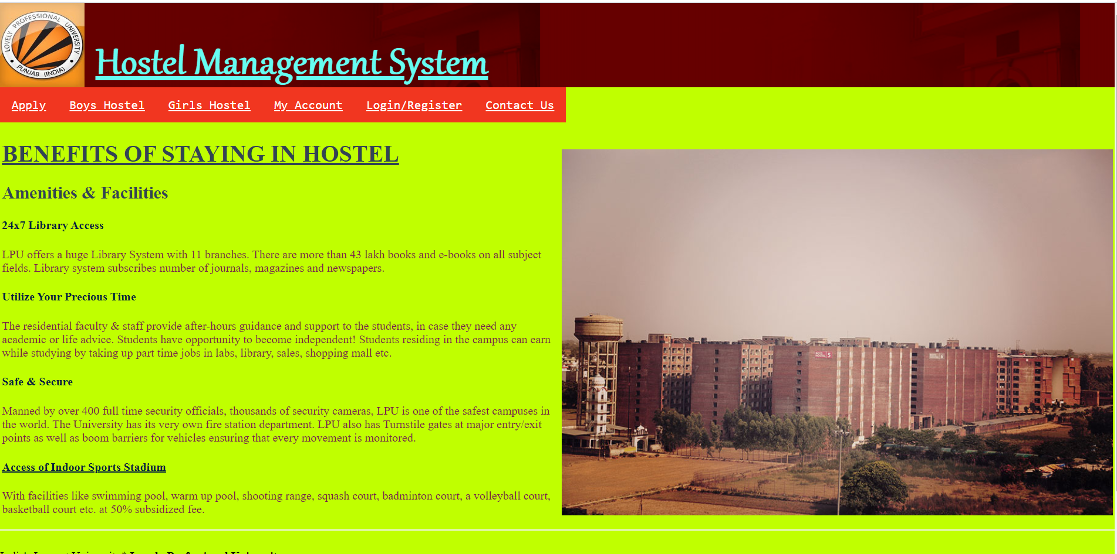

Fig 1.: HOME MODULE

* Apply Module :

Using the apply module user can use different options such as there is a portal for the hostel room booking for existing students and also a different portal for the hostel room booking for new students. The students have also been given the facility for checking the availability of rooms and also book hostels rooms for short period.

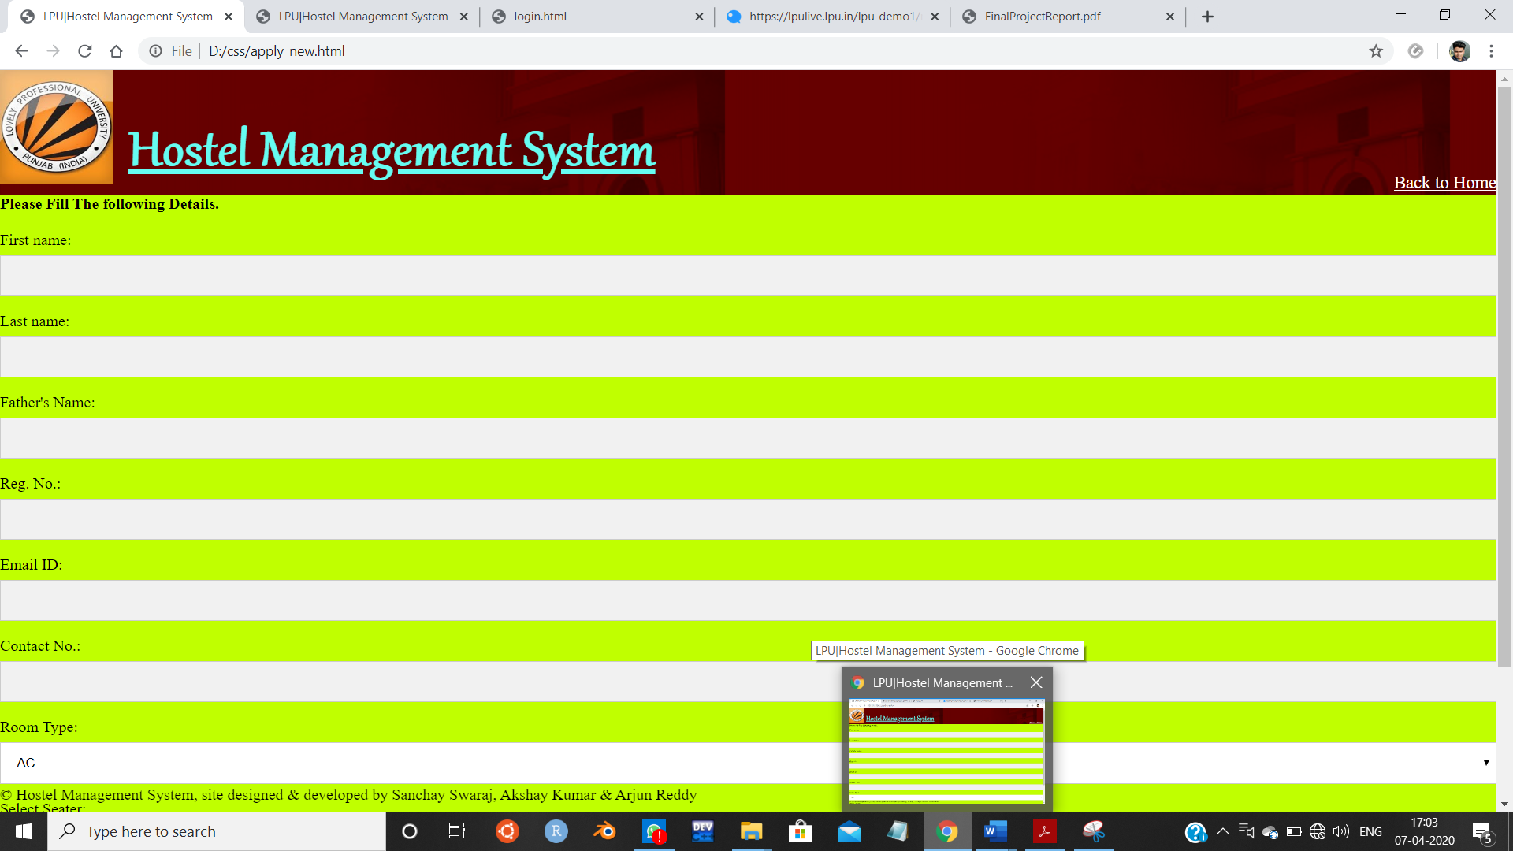

Fig. 2.: NEW APPLCATION MODULE

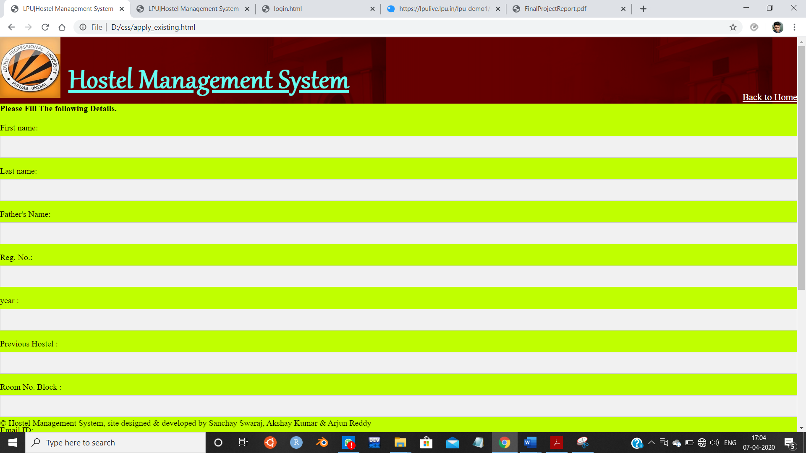

Fig. 3.: EXISTING USERS MODULE

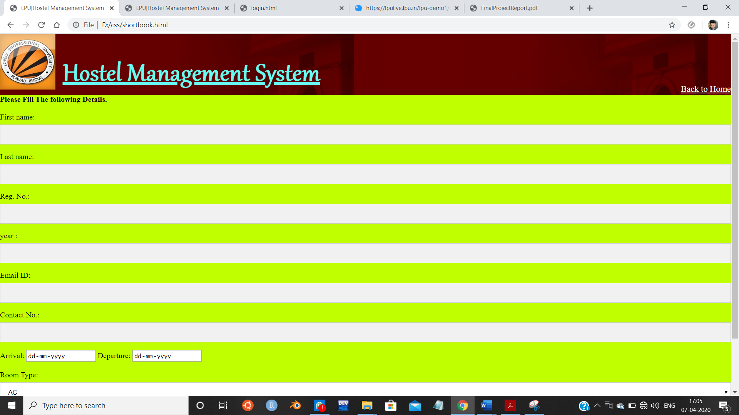

Fig. 4.: SHORT TERM BOOKING MODULE

* Boys Hostel:

Using the boys hostel menu in the portal user can get information about the different types of rooms and hostels available in he university, and their fees. Through this module user can also get information about the different facilities with the residential facilities such as mess, laundry , indoor stadium and gym and their fees respectively.

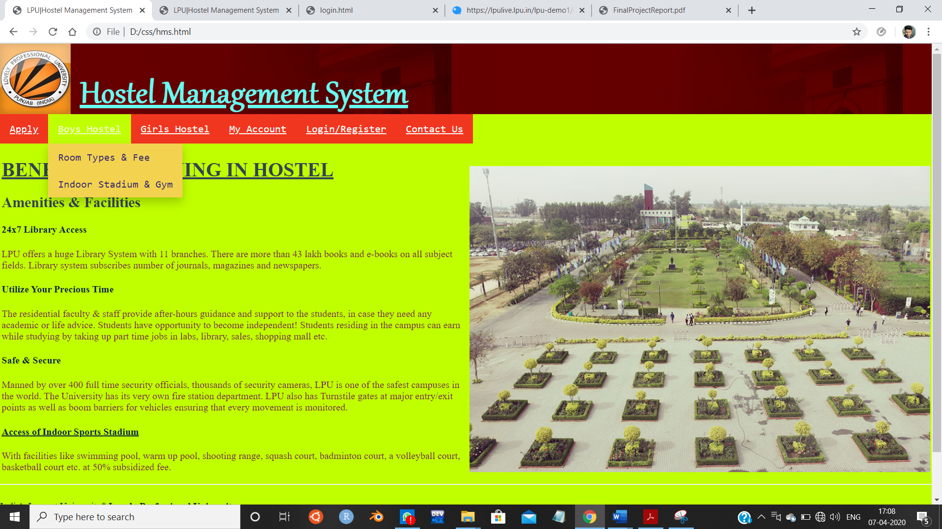

FIG. 5.: DIFFERENT SUB MENU UNDER TOP MENU BAR FOR BOYS HOSTEL MENU

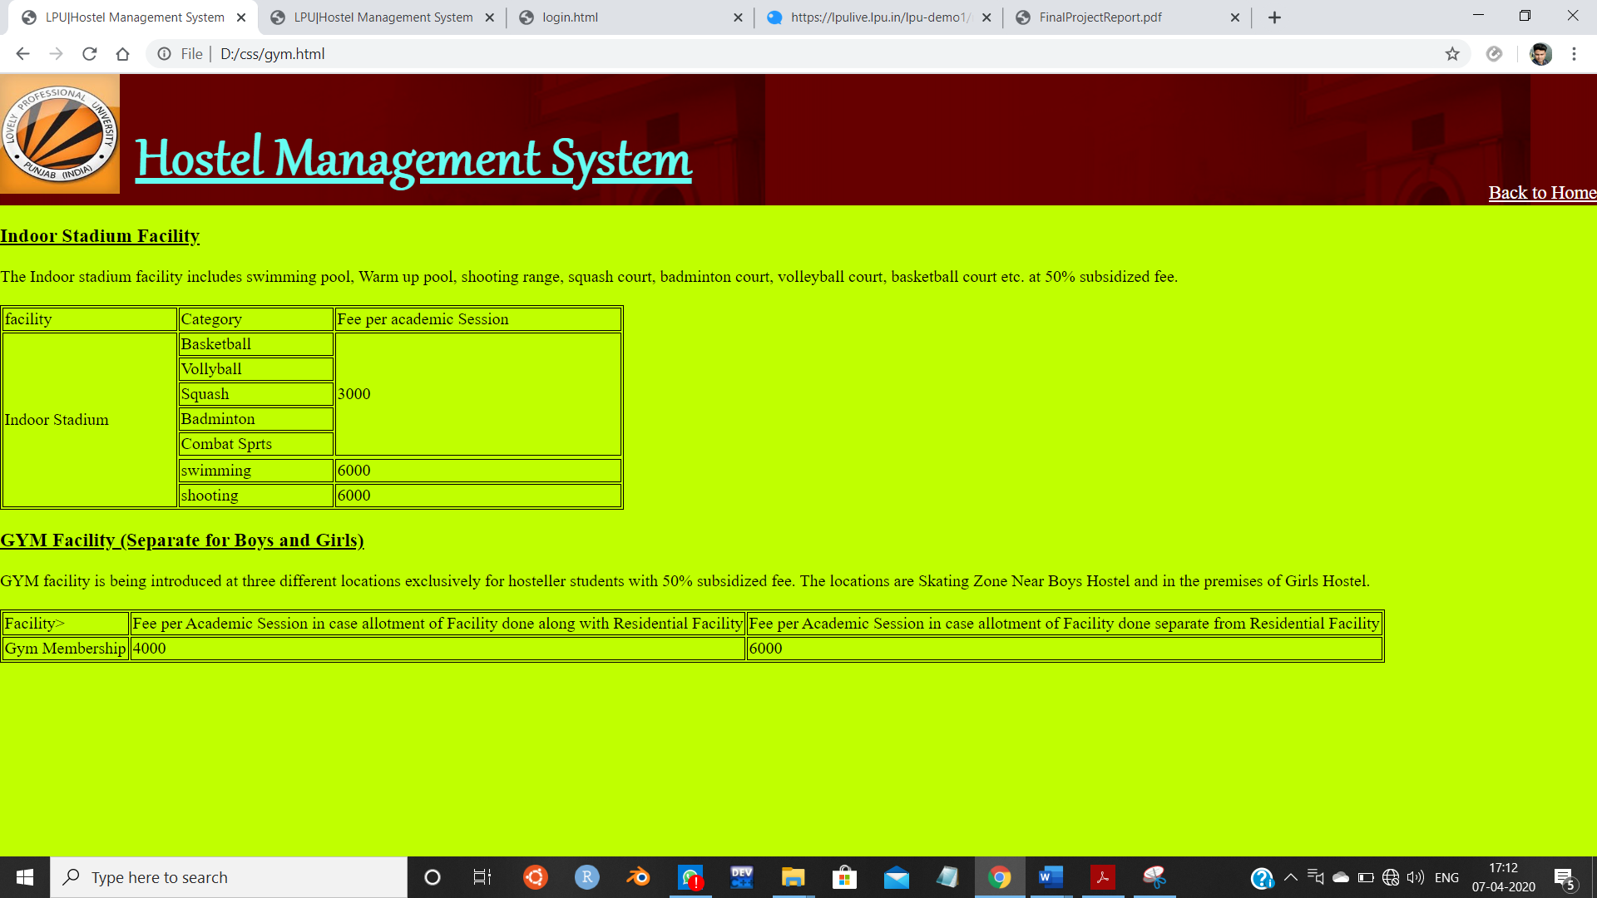

FIG. 6.: GYM AND INDOOR STADIUM FEE DESCRIPTION

* Girls Hostel:

Using the girls hostel menu in the portal user can get information about the different types of rooms and hostels available in he university, and their fees. Through this module user can also get information about the different facilities with the residential facilities such as mess, laundry , indoor stadium and gym and their fees .

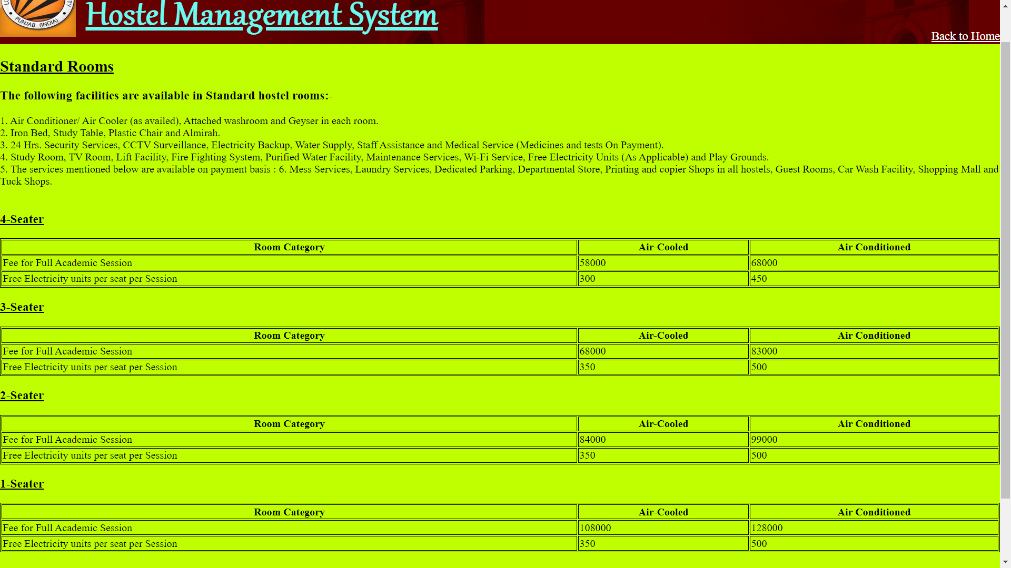

FIG . 7.: ROOM TYPE AND FEE DESCRIPTION UNDER GIRLS HOSTEL MODULE

* My Account:

This module is used to store student details i.e. information like profile details, contact information, educational details etc. Users can search according different criteria such as name, course, room number etc. In the My Account Module user can get information about the user details , and different other options . This displays fee records, student dues status and balance amount status. It is also used to renew students rent every semester. This is provided to view summary detail regarding hostel fees and bills. Students can check hostel fees and bill details by entering the unique hostel ID.

* Login/Register:

This Module helps existing user to Log in to their account and the New student to register and create an new account.

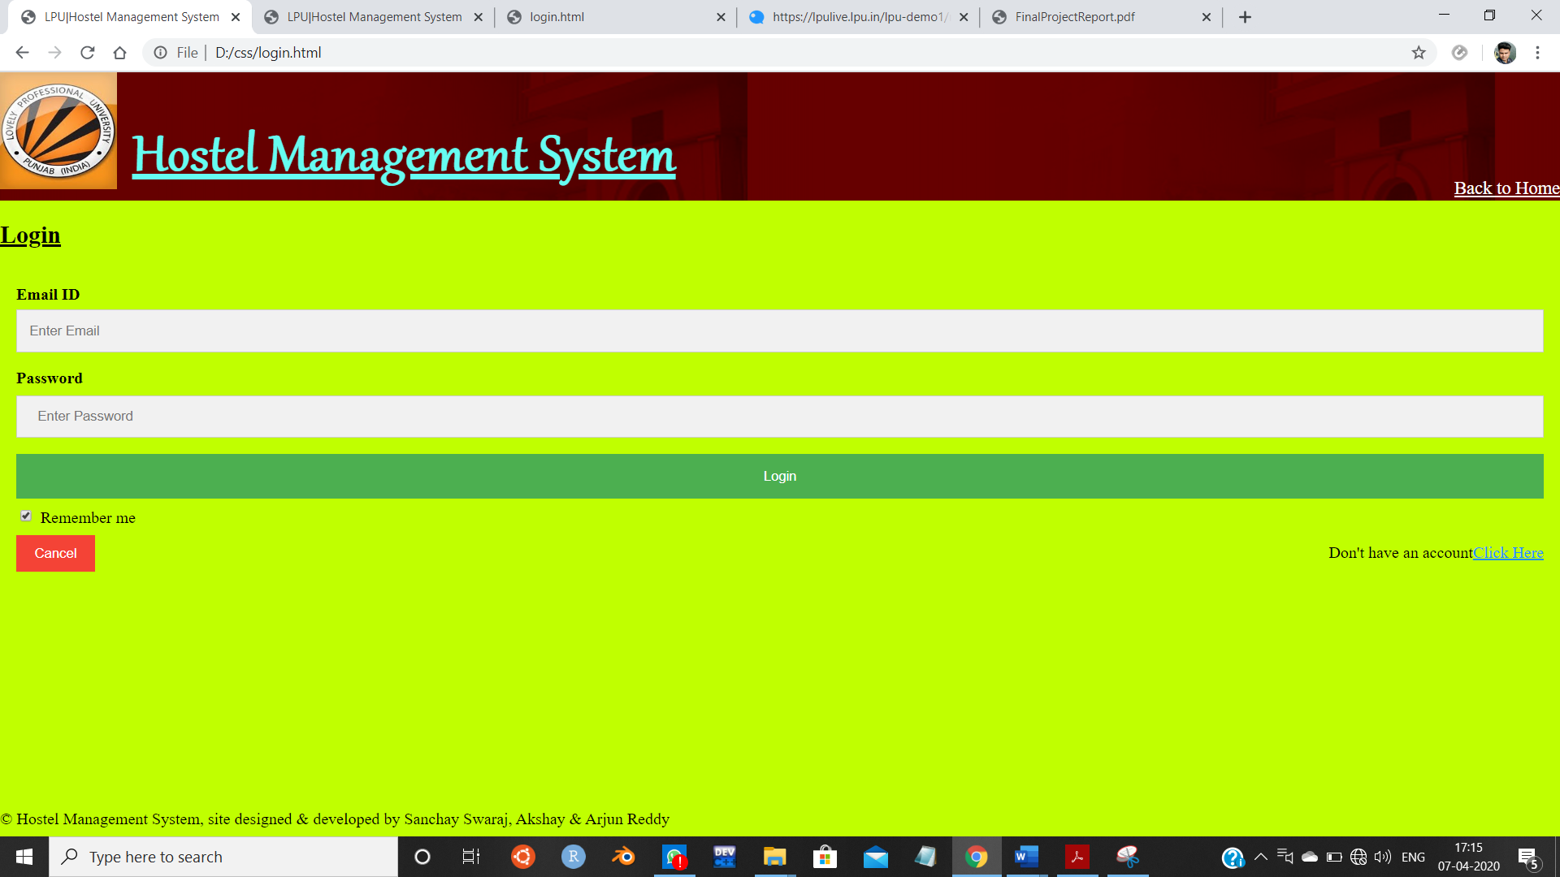

Fig. 8.: LOGIN PAGE MODULE

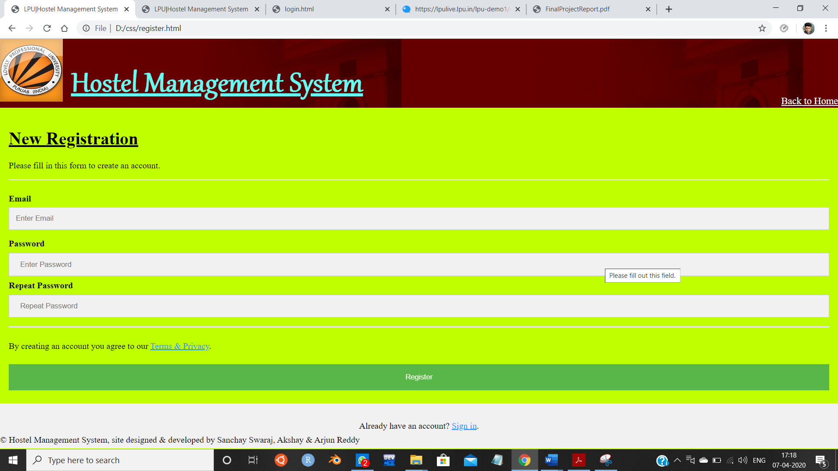

Fig. 9.: New use Registration Module

* Contact Us:

Through this contact us platform students can contact or communicate with the Hostel Accommodation System via online or offline by listing out their issues regarding their respective Hostels and also can give their feedback if they think that any of the services need to be improved. This Module describes about the different ways of contacting the university and also a form to fill the details and the query to get a resolution.

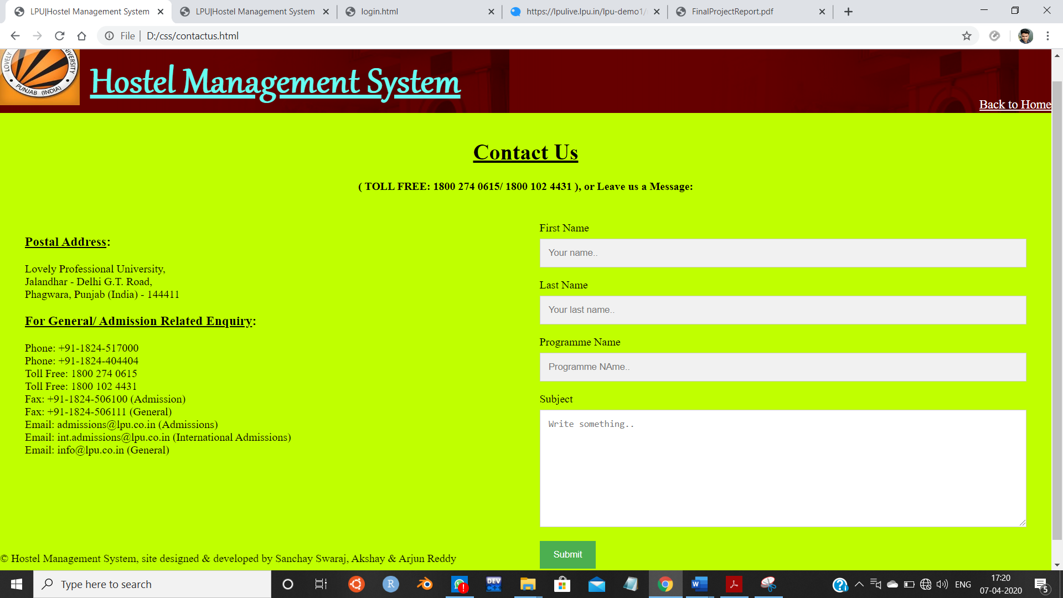

FIG 10.: CONTACT US MODULE

**Division of Work Among the Students:**

1. Sanchay Swaraj (11905805) : Written HTML, CSS & Javascript Code for the Entire Website , Formatting of website and completion of final Report.
2. k. Sai Arjun Reddy (11905733) : Completed synopsis and created linked html pages and final report completion.
3. Akshay Kumar (11905779) : Created video recording of project on Loom and Formatting the website and completion of the final report.

**Technologies and Framework used**

* Operating System – Windows 10
* Browser – Chrome/ Mozilla Firefox
* Text Editor – Notepad
* Html
* CSS
* Javascript

**SWOT Analysis achieved in project:**

* This project offers user to enter the data through a simple, eco-friendly & interactive manner.
* User is provided with the option only to view the records which he/she has entered earlier.
* Data storage and retrieval will become more faster and easier to maintain
* Learning the application of HTML, CSS and Javascript
* Working with the different formatting tags in css and validation commands in html.